Project Design Phase
Solution Architecture
Date | November 2, 2025
Team ID | F53C03230D9D3649CD4402B24FF15FEB
project Name | Educational organization using ServiceNow

Architecture Overview:
This application is built as a custom application within the ServiceNow platform. It follows a simple, data-centric architecture where the user interface (forms) interacts directly with the custom tables, and client-side logic provides a dynamic user experience.
Component Diagram:
- User (Admin/Teacher): Interacts with the system via a web browser.
- ServiceNow UI (Forms & Lists):
  - Admission Form: u_admission
  - Student Progress Form: u_student_progress
- Business Logic (Client Scripts):
  - onLoad (Disable Fields)
  - onChange (Auto-populate, Pincode, Total, Percentage, Result)
- Data Model (Custom Tables):
  - u_salesforce (Base Table):
    - Contains common fields (Admin Number, Student Name, etc.).
    - Extensible: true
    - Number Maintenance: SAL...
  - u_admission (Child Table):
    - Extends u_salesforce.
    - Contains admission-specific fields (Admin Status, Pincode, etc.).

    - Has Process Flow attached.
  - u_student_progress (Related Table):
    - Contains a Reference Field to u_salesforce.
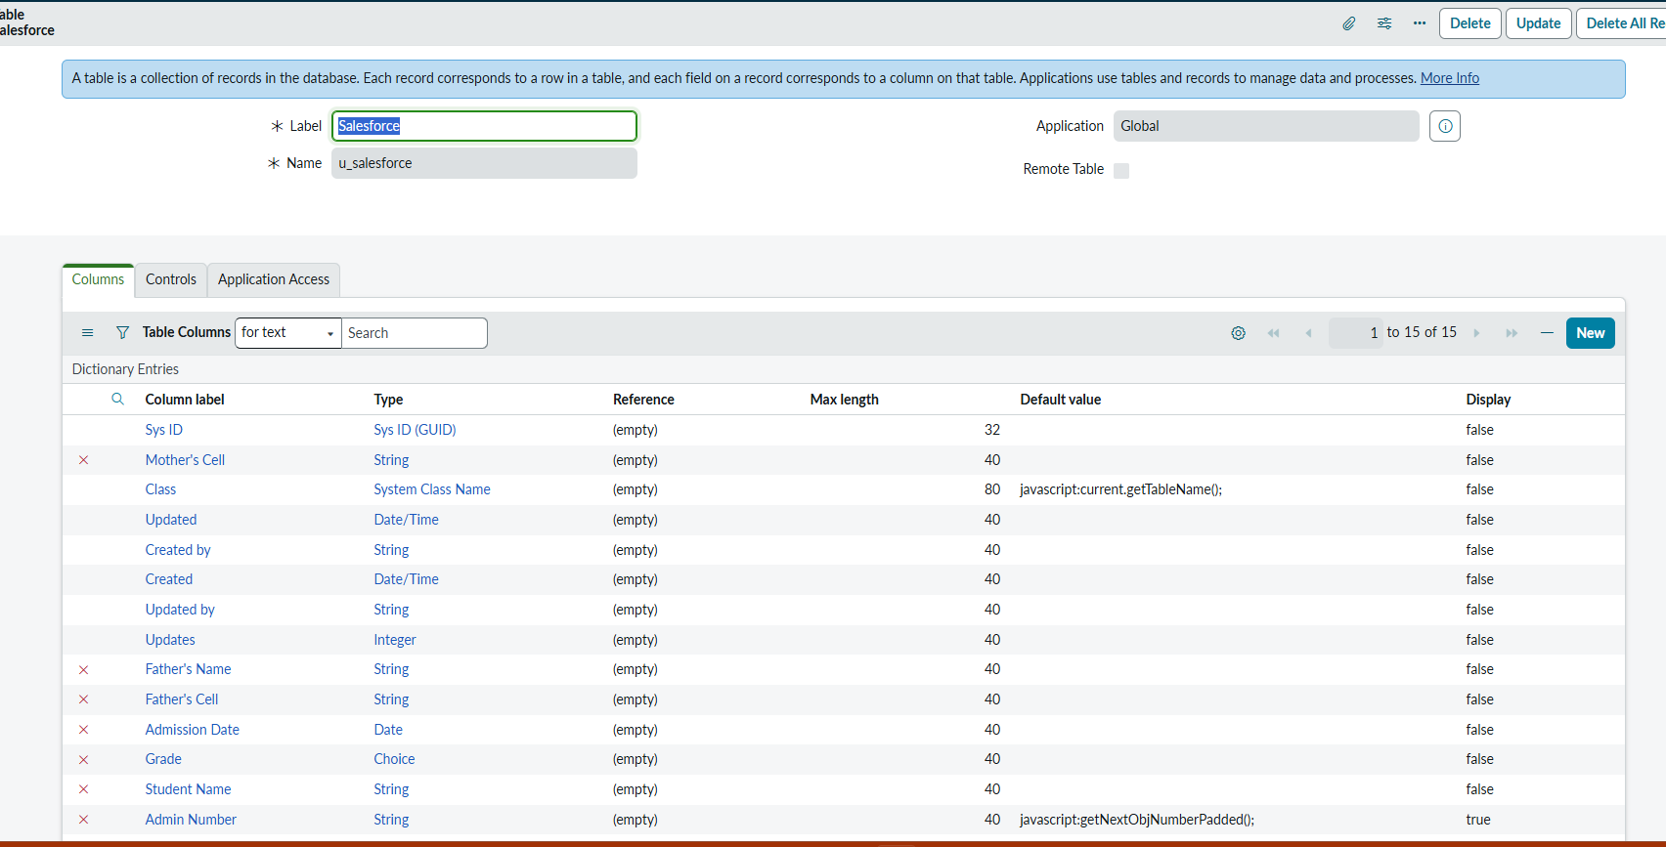
    - Contains subject and calculation fields (Maths, English, Total, etc.).

Data Relationship Diagram:
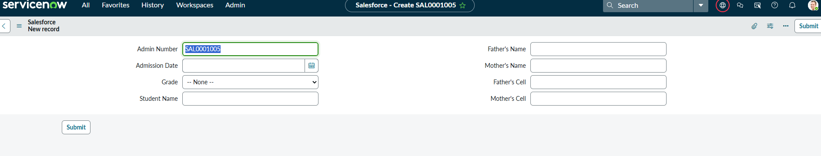
(u_salesforce) 1 ---- 1 (u_admission)
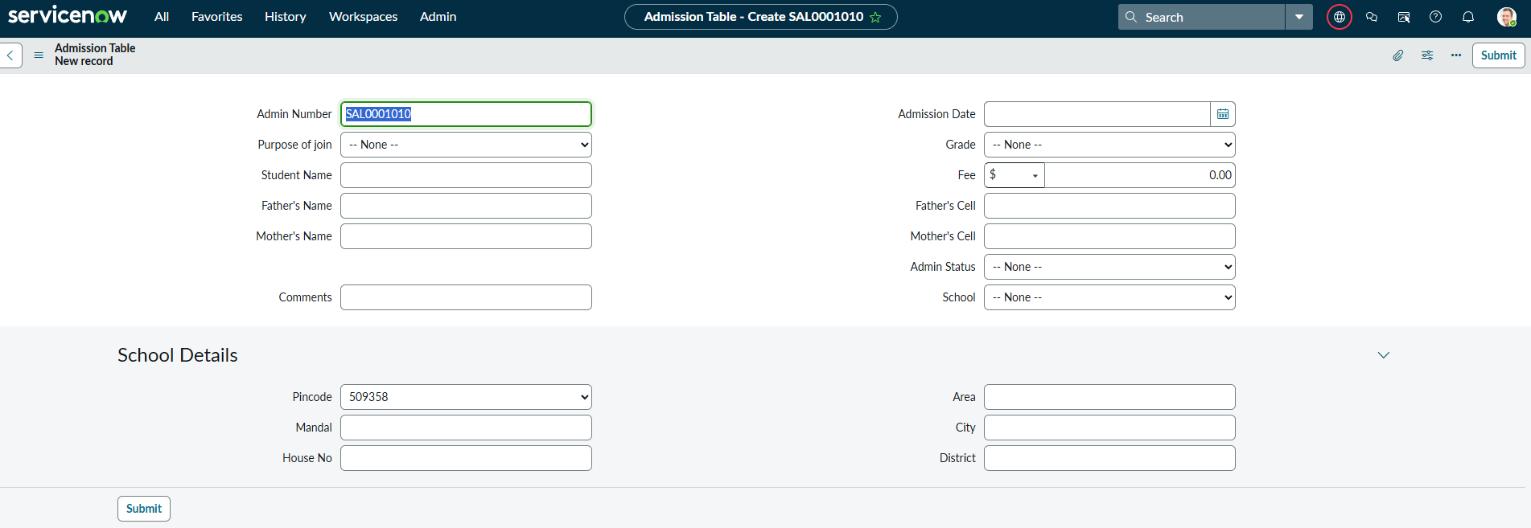
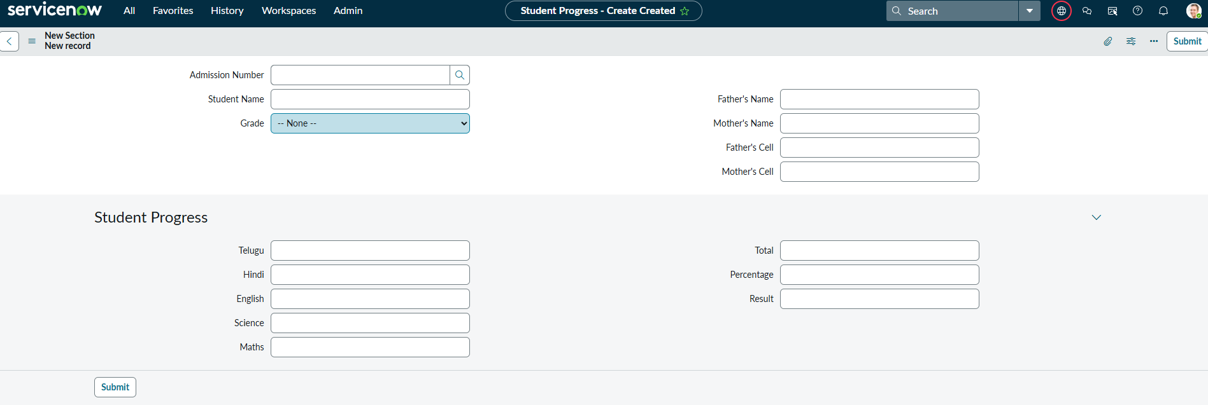
This is a 1-to-1 relationship because Admission extends Salesforce.
(u_salesforce) 1 ---- N (u_student_progress)
This is a 1-to-Many relationship, as one student (one Salesforce record) can have many progress reports.
